An Assignment on Computer fundamentals

---History of computer---

The word "computer" was first recorded as being used in [1613](http://www.computerhope.com/history/1600.htm) and originally was used to describe a human who performed calculations or computations. The definition of a computer remained the same until the end of the 19th century, when the industrial revolution gave rise to machines whose primary purpose was calculating.

---Difference Engine---

In [1822](http://www.computerhope.com/history/1800.htm), [Charles Babbage](http://www.computerhope.com/people/charles_babbage.htm) conceptualized and began developing the [Difference Engine](http://www.computerhope.com/jargon/d/diffengi.htm), considered to be the first automatic computing machine. The Difference Engine was capable of computing several sets of numbers and making [hard copies](http://www.computerhope.com/jargon/h/hardcopy.htm) of the results. Babbage received some help with development of the Difference Engine from [Ada Lovelace](http://www.computerhope.com/people/ada_lovelace.htm), considered by many to be the first computer programmer for her work and notes on the Difference Engine. Unfortunately, because of funding, Babbage was never able to complete a full-scale functional version of this machine. In June of [1991](http://www.computerhope.com/history/1991.htm), the London Science Museum completed the Difference Engine No 2 for the bicentennial year of Babbage's birth and later completed the printing mechanism in 2000.

[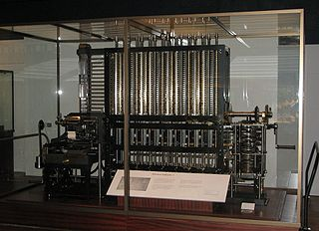](https://en.wikipedia.org/wiki/File:Babbage_Difference_Engine.jpg)

---Analytical Engine---

In [1837](http://www.computerhope.com/history/1800.htm), Charles Babbage proposed the first general mechanical computer, the [**Analytical Engine**](http://www.computerhope.com/jargon/a/analyten.htm). The Analytical Engine contained an [Arithmetic Logic Unit (ALU)](http://www.computerhope.com/jargon/a/alu.htm), basic [flow control](http://www.computerhope.com/jargon/f/flowcont.htm), [punch cards](http://www.computerhope.com/jargon/p/punccard.htm) (inspired by the [Jacquard Loom](http://www.computerhope.com/jargon/j/jacquard-loom.htm)), and integrated [memory](http://www.computerhope.com/jargon/m/memory.htm) and is the first general-purpose computer concept. Unfortunately, because of funding issues, this computer was also never built while Charles Babbage was alive. In [1910](http://www.computerhope.com/history/190040.htm), Henry Babbage, Charles Babbage's youngest son, was able to complete a portion of this machine and was able to perform basic calculations.

[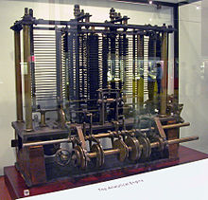](https://en.wikipedia.org/wiki/File:AnalyticalMachine_Babbage_London.jpg)

---First programmable computer---

The [**Z1**](http://www.computerhope.com/jargon/z/z1.htm) was created by German [Konrad Zuse](http://www.computerhope.com/people/konrad_zuse.htm) in his parents' living room between [1936](http://www.computerhope.com/history/190040.htm)and 1938. It is considered to be the first electro-mechanical [binary](http://www.computerhope.com/jargon/b/binary.htm) programmable computer, and the first really functional modern computer.

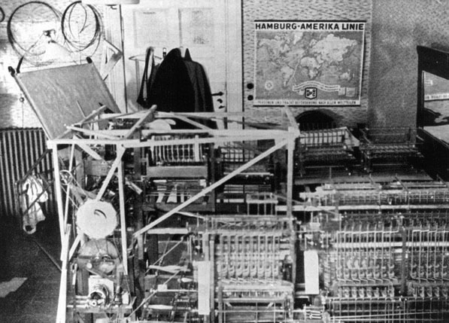

---The first electric programmable computer---

The **Colossus** was the first electric programmable computer, developed by Tommy Flowers, and first demonstrated in December [1943](http://www.computerhope.com/history/1943.htm). The Colossus was created to help the British code breakers read encrypted German messages. 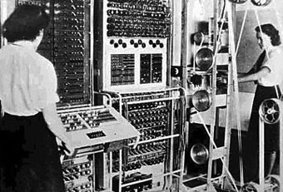

---The first digital computer---

Short for **Atanasoff-Berry Computer**, the [**ABC**](http://www.computerhope.com/jargon/a/abc.htm) began development by Professor [John Vincent Atanasoff](http://www.computerhope.com/people/john_atanasoff.htm) and graduate student Cliff Berry in [1937](http://www.computerhope.com/history/190040.htm). Its development continued until 1942 at the Iowa State College (now Iowa State University).

The ABC was an electrical computer that used [vacuum tubes](http://www.computerhope.com/jargon/v/vacuumtu.htm) for digital computation, including binary math and [Boolean](http://www.computerhope.com/jargon/b/boolean.htm) logic and had no [CPU](http://www.computerhope.com/jargon/c/cpu.htm). On October 19, [1973](http://www.computerhope.com/history/1973.htm), the US Federal Judge Earl R. Larson signed his decision that the ENIAC patent by J. Presper Eckert and John Mauchly was invalid and named Atanasoff the inventor of the electronic digital computer.

The [**ENIAC**](http://www.computerhope.com/jargon/e/eniac.htm) was invented by [J. Presper Eckert](http://www.computerhope.com/people/john_eckert.htm) and [John Mauchly](http://www.computerhope.com/people/john_mauchly.htm) at the University of Pennsylvania and began construction in [1943](http://www.computerhope.com/history/1943.htm) and was not completed until [1946](http://www.computerhope.com/history/1946.htm). It occupied about 1,800 square feet and used about 18,000 vacuum tubes, weighing almost 50 tons. Although the Judge ruled that the ABC computer was the first digital computer, many still consider the ENIAC to be the first digital computer because it was fully functional.

[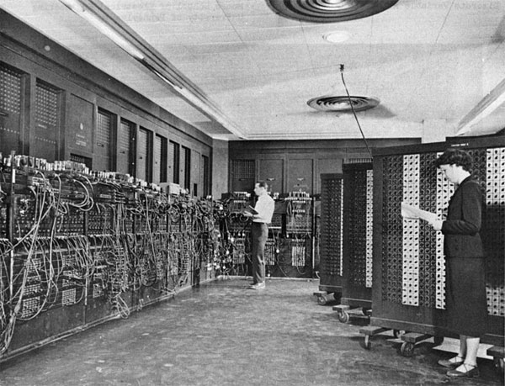](http://www.computerhope.com/jargon/e/eniac.htm)

---The first computer company---

The first computer company was the **Electronic Controls Company** and was founded in [1949](http://www.computerhope.com/history/1949.htm) by J. Presper Eckert and John Mauchly, the same individuals who helped create the ENIAC computer. The company was later renamed to EMCC or Eckert-Mauchly Computer Corporation and released a series of mainframe computers under the [UNIVAC](http://www.computerhope.com/jargon/u/univac.htm) name.

---The first personal computer---

In 1975, [Ed Roberts](http://www.computerhope.com/people/ed_roberts.htm) coined the term "personal computer" when he introduced the [**Altair**](http://www.computerhope.com/jargon/a/altair.htm)**8800**. Although the first personal computer is considered by many to be the **KENBAK-1**, which was first introduced for $750 in 1971. The computer relied on a series of switches for inputting data and output data by turning on and off a series of lights.

[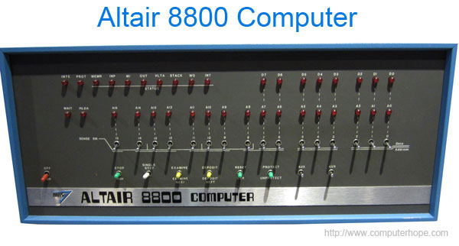](http://www.computerhope.com/jargon/a/altair.htm)

---The first laptop or portable computer---

The [**IBM 5100**](http://www.computerhope.com/jargon/i/ibm5100.htm) is the first portable computer, which was released on September [1975](http://www.computerhope.com/history/1975.htm). The computer weighed 55 pounds and had a five inch [CRT](http://www.computerhope.com/jargon/c/crt.htm) display, [tape drive](http://www.computerhope.com/jargon/t/tape.htm), 1.9MHz PALM processor, and 64KB of RAM. In the picture is an ad of the IBM 5100 taken from a November 1975 issue of Scientific America.

The first truly portable computer or laptop is considered to be the **Osborne I**, which was released on April 1981 and developed by [Adam Osborne](http://www.computerhope.com/people/adam_osborne.htm). The Osborne I weighed 24.5 pounds, had a 5-inch display, 64 KB of memory, two 5 1/4" floppy drives, ran the [CP/M](http://www.computerhope.com/jargon/c/cpm.htm) 2.2 operating system, included a [modem](http://www.computerhope.com/jargon/m/modem.htm), and cost US$1,795.

The [IBM](http://www.computerhope.com/comp/ibm.htm) PC Division (PCD) later released the IBM portable in [1984](http://www.computerhope.com/history/1984.htm), it's first portable computer that weighed in at 30 pounds. Later in [1986](http://www.computerhope.com/history/1986.htm), IBM PCD announced it's first [laptop](http://www.computerhope.com/jargon/l/laptop.htm) computer, the **PC Convertible**, weighing 12 pounds. Finally, in 1994, IBM introduced the IBM ThinkPad 775CD, the first notebook with an integrated [CD-ROM](http://www.computerhope.com/jargon/c/cdrom.htm).